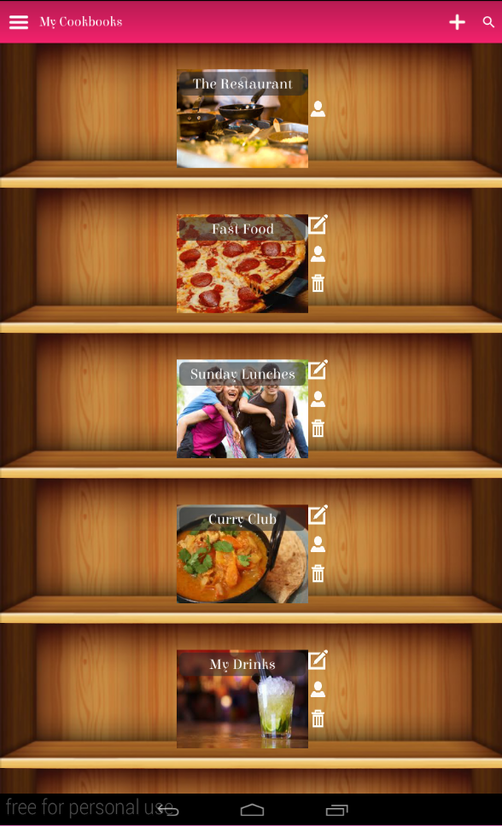

**Image Click** – Clicking the image of the cookbook takes the user inside the cookbook

**Cookbook View For Contributors** – Cookbook contributors only have access to view contributors and to add cookbooks

**Cookbook View For Owners** – Cookbook owners can manage contributors as well as delete, add and edit cookbooks

**Plus icon** – Enables user to add new cookbook to the shelf

**Dustbin icon** – Enables user to view or manage contributors

**User icon** – Enables user to view or manage contributors

**Pen and paper** **icon** – Enables user to edit the cookbook

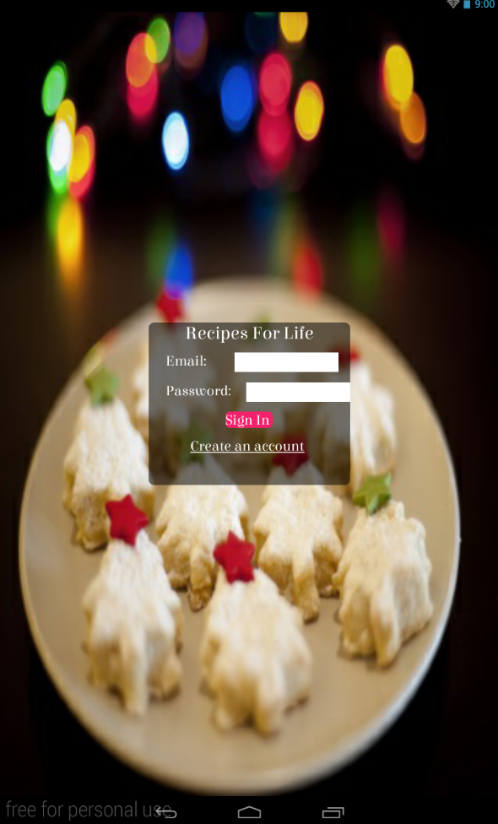

**Sign in button** – The sign in button when pressed logs the user into the app if they have the right credentials

**Create An Account Link** –Displays a dialog enabling user to create an account

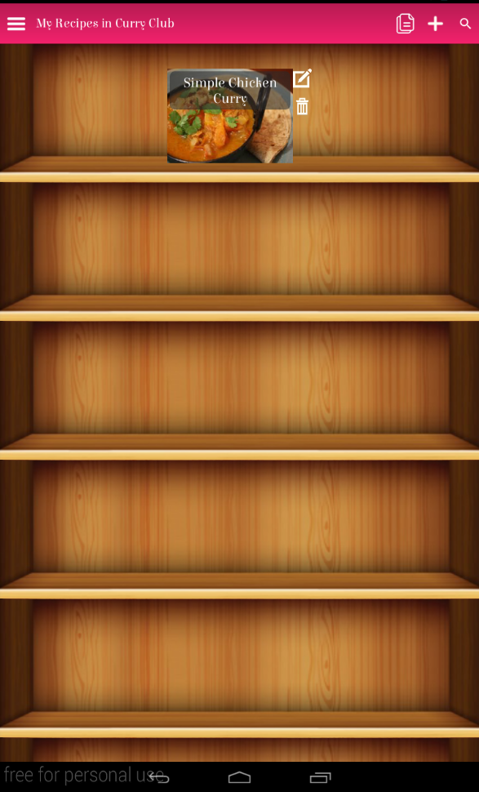

**Recipe Image Click –** Clicking the image takes you to view the recipe

**Dustbin Icon** –When clicked enables the user to delete the recipe

**Pen And Paper Icon** –When clicked takes the user to a screen where they can edit the recipe

**Plus Icon** –When clicked enables the user to add a recipe

**Copy Icon –** Enables the user to clone any recipe they own into the shelf

**Clone Icon –** Clicking the icon enables the user to clone the recipe under a new name

**Full screen Icon –** Enables the view of the recipe to be in full screen

**Share Icon –** Enables a picture and some words about the recipe to be shared

**Font Icons -** Enable recipe views font to be increased or decreased

**Brightness Icon –** Enables screen sleep to be toggled on/off

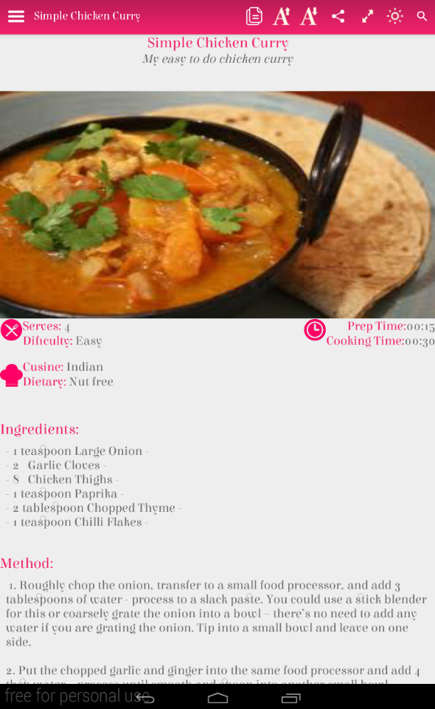

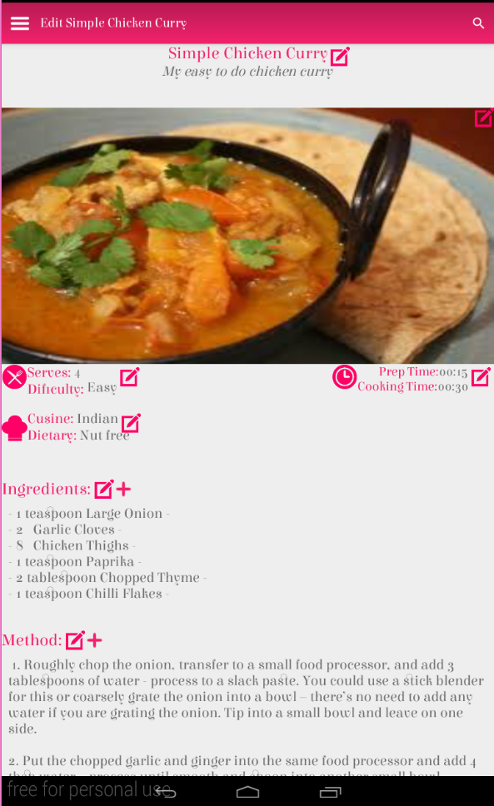

**Pen and paper icon –** Click to edit this section of the recipe.

**Plus icon –** Click to add a new ingredient or step.

**Menu icon –** Enables opening / closing of navigation bar.

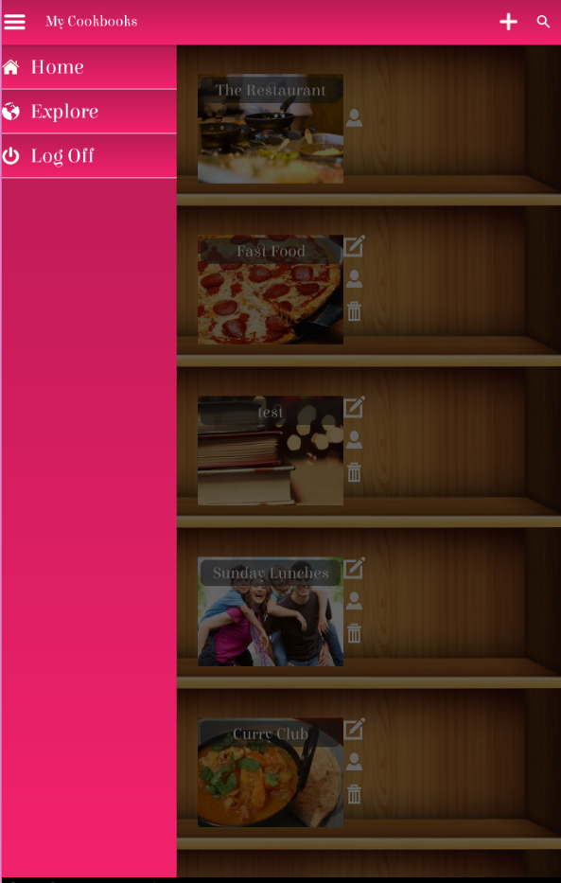

**Navigation Bar –** When an item is clicked in the navigation bar it takes you to a new page.